**“WOMEN SELF DEFENCE SHOE”**

**Project Exhibition -II**

Submitted in partial fulfillment for the award of the degree of

**Bachelor of Technology**

**In**

**ELECTRONICS AND COMMUNICATION ENGENEERING**

Submitted to

**VIT BHOPAL UNIVERSITY (M.P.)**



**Submitted by**

**NAME OF STUDENT**

**MUSKAN SAHU (18BEC10053)**

**SHIVANI SAHU(18BEC10074)**

**VARSHA SUDARSHAN(18BEC10089)**

**UTKARSH GUPTA(18BEC10088)**

**ANJALI PRAJAPATI(18BEC10007)**

**SUSHANT SHARMA(18BEC10084)**

Under the Supervision of

Prof. Pallabi Sarkar

**SCHOOL OF ELECTRICAL & ELECTRONICS ENGG.**

**VIT BHOPAL UNIVERSITY**

**BHOPAL (M.P.)-466114**

**February-20**

**(i)**



**VIT BHOPAL UNIVERSITY BHOPAL (M.P.) 466114**

SCHOOL OF ELECTRICAL & ELECTRONICS ENGG.

**CANDIDATE’S DECLARATION**

We hereby declare that the Dissertation entitled “Women Self Defence Shoe" is our own work conducted under the supervision of Prof. Pallabi Sarkar, Designation, Name of Department at VIT University, Bhopal.

We further declare that to the best of my knowledge this report does not contain any part of work that has been submitted for the award of any degree either in this university or in other university / Deemed University without proper citation.

**Shivani Sahu (18BEC10074)**

**Muskan Sahu (18BEC10053)**

**Varsha Sudarshan (18BEC10089)**

**Utkarsh Gupta (18BEC10088)**

**Anjali Prajapati (18BEC10007)**

**Sushant Sharma (18BEC100084)**

This is to certify that the above statement made by the candidates is correct to the best of my knowledge.

Date: 19/02/20 20

**Dr.Pallabi Sarkar**

**Assistant Professor, School of Electrical and Electronics Engineering**

**(ii)**



**VIT UNIVERSITY BHOPAL (M.P.) – 466114**

SCHOOL OF ELECTRICAL & ELECTRONICS ENGG.

**CERTIFICATE**

This is to certify that the work embodied in this Project Exhibition -II report entitled **“Women Self Defence Shoe”** has been satisfactorily completed by Muskan Sahu (18BEC10053), Shivani Sahu (18BEC10074), Varsha Sudarshan (18BEC10089) ,Utkarsh Gupta (18BEC1088) , Anjali Prajapati(18BEC10007) , Sushant Sharma(18BEC10084) in the School of Electrical & Electronics Engineering of Electronics and Communication Engineering at VIT University, Bhopal. This work is a bonafide piece of work, carried out under my/our guidance in the School of of Electrical & Electronics Engineering for the partial fulfilment of the degree of Bachelor of Technology.

**Dr. Pallabi Sarkar**

**Assistant Professor,SEEE**

Forwarded by Approved by

**Dr. Ribu Mathew Dr. Ribu Mathew**

**Program Chair Program Chair**

**(iii)**

**Acknowledgement**

We have taken efforts in this project. However, it would not have been possible without the kind support and help of individuals and institution. We would like to extend my sincere thanks to all of them.

We are highly indebted to Prof. Pallabi Sarkar for his guidance and constant supervision as well as for providing necessary information regarding the project & also for his support in completing the project. We would like to express my gratitude towards our parents & member of VIT Bhopal University for their kind co-operation and encouragement which help us in completion of this project.

We would like to express our special gratitude and thanks to institution persons for giving us such attention and time. Our thanks and appreciations also go to our colleague in developing the project and people who have willingly helped us out with their abilities.

**(iv)**

**Executive Summary**

Now a days, we see a number of cases of harassment of women . These cases occur as less safety measures for women are being used. Most of the cases that we come across mainly occurs at places that are quiet and deserted, where there is no one around to help. And this problem is growing at a very high rate at different places in our country. To prevent this problem we have designed a shoe which will help a women to send a distress message and her live location to some pre- registered phone numbers so that they can come or can arrange some help for the women in danger. The purpose of the project is to develop and design a safety device for women with high reliability to prevent harassment of women at a large scale. In this we used GSM Module, arduino board microcontroller , GPS tracker ,power circuit.

**(v)**

**List of figures**

|  |  |  |
| --- | --- | --- |
| Figure No. | Figure Contents | Page No. |
| 1.0 | Working principle |  |
| 2.0 | Embedded System |  |
| 3.0 | Miicrocontroller ATMEGA328 | — |
| 4.0 | Power Circuit | 56 |
| 5.0 | GSM and GPS | 91 |
| 6.0 | Safety or defence system | 35 |
| 7.0 | Flow chart/Block diagram |  |

**(vi)**

Table of Contents

Front Page i

Candidate’s Declaration ii

Certificate iii

Acknowledgement iv

Executive Summary v

List of Figures vi

List of Tables vii

**Contents**

1. INTRODUCTION
2. 1.1 Objective
3. LITERATURE REVIEW
4. PROBLEM FORMULATION AND PROPOSED
5. METHODOLOGY
   1. Working
   2. Embedded System
   3. Arduino NANO ATMEGA328
   4. Power Circuit
   5. GSM Module

6 Circuit Diagram and Flowchart

List of Components /Software/Tools used 20

RESULTS AND DISCUSSION 21

CONCLUSION AND FUTURE SCOPE 22

REFERENCES

APPENDIXES

Appendix I

Appendix II

**(7)**

**CHAPTER 1: INTRODUCTION**

This thesis presents the design and implementation of a Shoe for the use of women in danger conditions. The research described in this thesis was carried out as part of a larger project aimed to demonstrate self-defense and alert systems for women to avoid crimes in alone and badly lit areas. Specific contributions of the thesis include an assessment of the GSM Module and GPS tracking system. Simulation and testing results show the effectiveness of the approach.

* 1. Objective :-

1. Implementation of a real time monitoring device can solve the problem to an extent.

1. The basic approach is to intimate instant location and a distress message to the cops and registered number like parents, friends, media, and women cell etc. so that unfortunate incidents would be averted and to provide real time evidence for swift action against the perpetrators of crime against women
2. Shock mechanism to produce non-lethal electric shock in emergency situations to deter the attacker.

**(8)**

CHAPTER 2: LITERATURE SURVEY

GSM (Global System for Mobile communication) Module can be used to send distress message to the numbers pre-registered in the SIM used in the module. The GSM standard was developed for setting protocols for second generation (2G) digital cellular networks. In GSM, geographical area is divided into hexagonal cells whose side depends upon power of transmitter and load on transmitter (number of end user). At the center of cell, there is a base station consisting of a transceiver (combination of transmitter and receiver) and an antenna.

**Architecture:-**

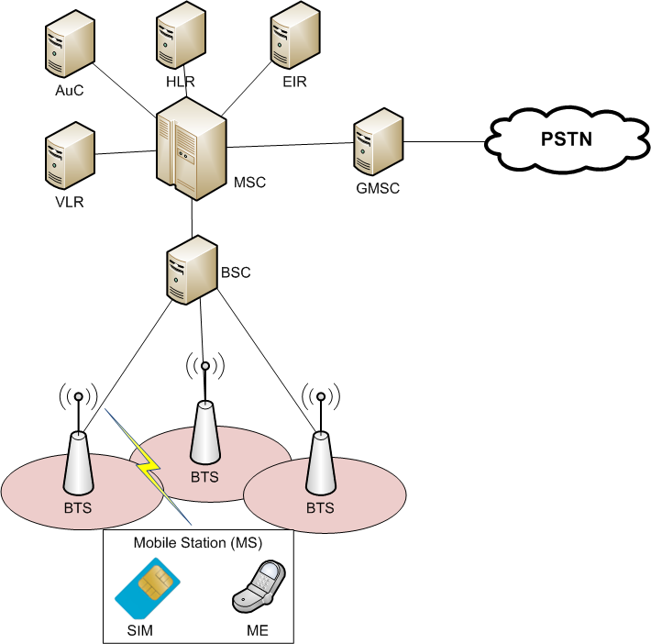

The GSM architecture is divided into Radio Subsystem, Network and Switching Subsystem and the Operation Subsystem. The radio sub system consists of the Mobile Station and Base Station Subsystem.

The mobile station is generally the mobile phone which consists of a transceiver, display and a processor. Each handheld or portable mobile station consists of a unique identity stored in a module known as SIM (Subscriber Identity Chip). It is a small microchip which is inserted in the mobile phone and contains the database regarding the mobile station.

**(9)**

CHAPTER 3: WORK MODULE

|  |  |  |  |
| --- | --- | --- | --- |
| S.NO | Particulars | Duration | Outcome |
| 1 | Module1(Give Name such as Literature survey with detail) | 8 days | Studying research papers based on this topic |
| 2 | Module2(Planning) | 7days | Studying hardware components |
| 3 | Module3(Design) | 10 days | Working on circuit diagram |
| 4 | Module4(Implementation) | 15 days | Assembling the hardware part |
| 5 | Module5(Validation) | 15 days | Testing and improving with report writing |

**(10)**

CHAPTER 4: Problem Formulation and Methodology:

**Problem Identification :-**

The principal problem has been the lack of women safety measures taken, this have resulted in the increase of crimes against women like harassment and other similar problems. In the past, many women became a victim of harassment and other disrespectful activities against them. Less use women safety measure have been identified to be the main cause of crimes against women in the past, yet there have been no cheap automated solutions available for testing purposes.

PROPOSED SYSTEM:

* The system comprises of sections which describes a quick responding, cost protection system for an individual and especially for women using which a woman in distress can call for help just with the press of a button on the shoes. Self Defense System for women safety is like this for Women. It has the ability to help women with technologies that are embedded into shoes.
* The women wearing this shoes , in case of any harassment or when she finds that someone is going to harass, she presses a button that is located on the shoes and location information is sent as SMS alert to a few predefined emergency numbers And soon help is on its way! The system will consist of embedded hardware and software co-designed for this dedicated application.

**(11)**

CHAPTER 5: METHODOLOGY

5.1 Working

* This project is designed with ATmega328. This Project presents a women safety detection system using GPS tracking and GSM Modules.
* The system can be interconnected with the alarm system and alert the neighbors. This detection and messaging system is composed of a GPS receiver, Microcontroller and a GSM Module. GPS Receiver gets the location information from satellites in the form of latitude and longitude.
* The Microcontroller processes this information and this processed information is sent to the user using GSM Module.
* When a woman is in danger and in need of self-defense then she can press the switch which is allotted to her. By pressing the switch, the entire system will be activated then immediately a message will be sent to concern person with location using GSM and GPS.

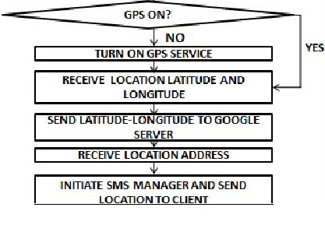

**(12)**

EMBEDDED SYSTEM

In the day-to-day life we come across a wide variety of consumer electronic

products. We are habituated to use them easily and flawlessly to our advantage. Common

examples are TV Remote Controllers, Mobile Phones, FAX machines, Xerox machines etc.

However, we seldom ponder over the technology behind each of them. Each of

these devices does have one or more programmable devices waiting to interact with the

environment as effectively as possible. These are a class of “embedded systems” and they

provide service in real time i.e. we need not have to wait too long for the action.

Embedded systems contain processing cores that are typically either

microcontrollers or digital signal processors (DSP). The key characteristic, however, is being

dedicated to handle a particular task. They may require very powerful processors and

extensive communication, for example air traffic control systems may usefully be viewed as

embedded, even though they involve mainframe computers and dedicated regional and

national networks between airports and radar sites (each of the radar probably includes one

or more embedded systems of its own).

Since the embedded system is dedicated to specific tasks, design engineers can

optimize it to reduce the size and cost of the product and increase the reliability and

performance. Some embedded systems are mass-produced, benefiting from economies of

scale.

Physically, embedded systems range from portable devices such as digital watches

and MP3 players, to large stationary installations like traffic lights, factory controllers, or the

systems controlling nuclear power plants. Complexity varies from low, with a single

microcontroller chip, to very high with multiple units, peripherals and networks mounted

inside a large chassis or enclosure.In general, &quot;embedded system&quot; is not a strictly definable term, as most systems have

**(13)**

some elements with embedded systems such as the operating systems and microprocessors

that power them, but they allow different applications to be loaded and peripherals to be

connected. Moreover, even systems that do not expose programmability as a primary

feature generally need to support software updates. On a continuum from &quot;general

purpose&quot; to &quot;embedded&quot;, large application systems will have subcomponents at most points

even if the system as a whole is &quot;designed to perform one or a few dedicated functions&quot;,

and is thus appropriate to call &quot;embedded&quot;.

Embedded systems are computers which are part of special-purpose devices. Due to

the limited duties this systems can be highly optimized to the particular needs. Traditionally

most of these systems are used for control and process measurement, as a side-effect of

higher integration of integrated circuits more complex applications can be solved by

embedded systems. To be able to solve these problems embedded systems are commonly

equipped with various kinds of peripherals.

Nowadays embedded systems can be found in devices from digital watches to

traffic-control systems. The broad range of applications with totally different requirements

leads to various implementation approaches. The range of hardware used in embedded

systems reaches from FPGAs to full blown desktop CPUs which are accompanied by special

purpose ICs such as DSPs. On the software side, depending on the needs, everything, from

logic fully implemented in hardware, to systems with own operating system and different

applications running on it, can be found.

**(14)**

5.2HARDWARE COMPONENT DESCRIPTION:

**5.2.1 Microcontroller ATMEGA 328**

The Arduino Nano is a small, complete, and breadboard-friendly board based on the ATmega328P; offers the same connectivity and specs of the UNO board in a smaller form factor. It can be powered via the Mini-B USB connection, 6-20V unregulated external power supply (pin 30), or 5V regulated external power supply (pin 27). The power source is automatically selected to the highest voltage source. Each of the 14 digital pins on the Nano can be used as an input or output, using pinMode(), digitalWrite(), and digitalRead() functions. They operate at 5 volts. Each pin can provide or receive a maximum of 40 mA and has an internal pull-up resistor (disconnected by default) of 20-50 kOhms

**Physical Characteristics**

It has 22 input/output pins in total. 14 of these pins are digital pins. Arduino Nano has 8 analogue pins. It has 6 PWM pins among the digital pins. It has a crystal oscillator of 16MHz. It's operating voltage varies from 5V to 12V.It also supports different ways of communication, which are:

* Serial Protocol.
* I2C Protocol.
* SPI Protocol.

It also has a mini USB Pin which is used to upload code. It also has a Reset button on it.

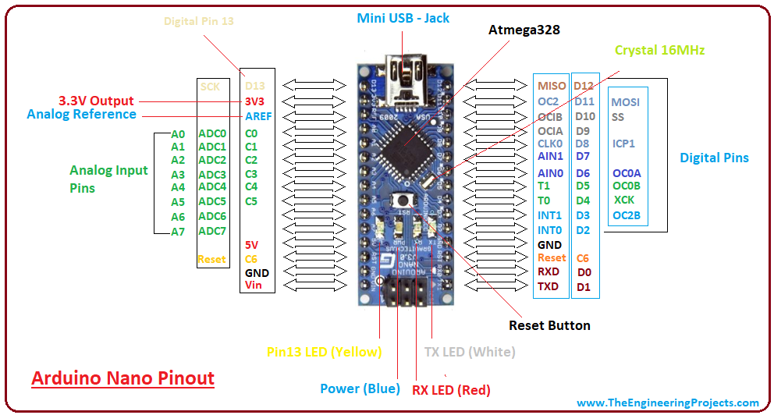

**(15)**

Features:-

1.Microcontroller-ATmega328

2.Operating Voltage- 5V

3.Input Voltage (recommended) - 7-12V

4.Input Voltage (limits)- 6-20V

5.Digital I/O Pins- 22 (of which 6 provide PWM output)

6.Analog Input Pins- 8

7.DC Current per I/O Pin - 40 mA

8.Flash Memory -32 KB (ATmega328) of which 2 KB used by bootloader

9.SRAM -2 KB (ATmega328)

10.EEPROM -1 KB (ATmega328)

11.Clock Speed -16 MHz

**(16)**

**Power:**

The Arduino Nano can be powered via the Mini-B USB connection, 6-20V unregulated external power supply (pin 30), or 5V regulated external power supply (pin 27). The power source is automatically selected to the highest voltage source.

**Power Supply Circuit:**

The whole electronic system is depend on the power supply for providing the required power for their operational circuit. For the microcontroller keyboard +5V are required. The power supply supplied the regulated output of +5V & non-regulated output of the +12V DC supply.

**GSM Module:**

The GSM module is used to send the distress message to the numbers registered in the module. A GSM module is a chip or circuit that will be used to establish communication between a mobile device or a computing machine and a GSM system. The modem (modulator-demodulator) is a critical part here.

These modules consist of a GSM module powered by a power supply circuit and communication interfaces (like RS-232, USB 2.0, and others) for computer. A GSM modem can be a dedicated modem device with a serial, USB or Bluetooth connection, or it can be a mobile phone that provides GSM modem capabilities.

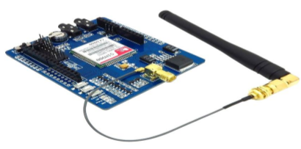

**(17)**

**List of Components/Software/Tools used**

**COMPONENTS :-**

ARDUINO NANO ATMEGA328

GSM MODULE

GPS TRACKING DEVICE

POWER CIRCUIT

WIRES

**Software Used**: Arduino IDE,Proteus

**Programming Language**- C/C++ based arduino coding

**Tools** – Shoulder,Glue

**(18)**

CHAPTER 6: RESULT AND DISCUSSION

In this paper, we have presented the GSM and GPS based safety shoe. Arduino NANO ATMEGA328 based alerting system in the safety shoe sends distress message just by clicking the button. This method having many advantages. The main advantage of this system is low power consumption, on time data operation and minimum analysis time. The simple idea can be implemented in large scale in order to have long run to facilitate better safety and provide effective testing model for achieving better results in the future.

Applications :-

It will be used by women to reduce the harassment and other disrespectful activities against them .

**(19)**

CHAPTER 7: CONCLUSION & FUTURE SCOPE

**Conclusion :-**

* Our effort behind this project is to design and fabricate a gadget which is so compact in itself that provide advantage of personal security system the emergency response system which is helpful for women in the incidents of crime.
* It is low cost system which can store the data of the members in the particular locality and provide immediate alert in case of crime against women.
* This provides women security. Being safe and secure is the demand of the day.

**Future Scope :-**

* Shock mechanism to produce non-lethal electric shock in emergency situations to deter the attacker.
* As the technological changes or new requirement from user to enhance the functionality of product may requires new version to introduce. Although the System is complete and working efficiently, new modules which enhance the system functionality can be added without any major changes to the entire system. By keeping this ability of the product 1 mind, an incremental process model has been used to design and develop the system. These are as follows
* Primary School Children Safety
* Vehicle Safety System Module
* Mobile and other valuables Safety System Module

**(20)**

Individual Contribution

|  |  |
| --- | --- |
| Anjali Prajapati | Tracking Device |
| Muskan Sahu | GSM/PPT |
| Shivani Sahu | Power Circuit/PPT |
| Sushant Sharma | Power Circuit/ Report |
| Utkarsh Gupta | Tracking Device/ Report |
| Varsha Sudarshan | GSM/ PPT |

**(21)**

**References**

[1]SelvamrajuSomalraju, VigneshwarMurali, GouravSaha, Dr.V.Vaidehi, “Robust Railway CrackDetection Scheme (RRCDS) Using LEDLDR Assembly,” IEEE Int. Conf. on Networking, Sensing and Control, vol. 6, iss. 3, pg. 453-460 , May2012 [2].[2]QiaoJian-hua;Li Lin-sheng; Zhang Jing-gang; “Design of Rail Surface Crack-detectingSystem Based on Linear CCD Sensor,” IEEEInt. Conf. on Networking, Sensing and Control, vol. 14, no. 4, pp. 961-970, April 2008 [3].[3]K. Vijayakumar, S.R. Wylie, J. D. Cullen, C.C. Wright, A.I. Shammaa, “ Non invasive rail track detection system using Microwave sensor,” Journalof App. Phy., vol. 9, iss. 11, pg. 1743-1749, June 2009.[4] Reenu George ,Divya Jose, Gokul T G , Keerthana Sunil , Varun A G,” Automatic Broken Track Detection Using IR Transmitter and Receiver”, International Journal of Advanced Research in Electrical, Electronics and Instrumentation Engineering(IJAREEIE), Volume 4, Issue 4,April 2015.[5] Prof. P.Navaraja, “CRACK DETECTION SYSTEM FOR RAILWAY TRACK BY USING ULTRASONIC AND PIR SENSOR”,International Journal of Advanced Information and Communication Technology (IJAICT) ,Volume -1, Issue-1, May 2014[6] Akhil n, Dinumohan , Fayis p, Sijagopinath,” Railway Crack Detection System”, International Research Journal of Engineering and Technology (IRJET) ,Volume: 03 Issue: 05 | May-2016[7] Rajesh lv, Manjunathgasuti, Mukundaswamy,” CRACK DETECTION AND COLLISION AVOIDANCE IN RAILWAY TRACKS” IRF International Conference,Volume 2,12th June, 2016.[8] Saurabh Srivastava , Ravi Prakash Chaurasia , Syed Imran Abbas , Prashant Sharma, Nitin Kumar Singh,” Railway Track Crack Detection Vehicle” International Advanced Research Journal in Science, Engineering and Technology(IARJSET), Vol. 4, Issue 2, February 2017.

[9] Ajeya G R, AshwiniN,KavithaS,Latha D C, ChaithraG, ”Robust Railway Track Crack Detection Scheme”, International Research Journal of Engineering and Technology (IRJET), Volume: 03 Issue: 05 | May-2016[10]S. Arivazhagan, R. NewlinShebiah, J. Salome Magdalene and G. Sushmitha, “Railway Track Derailment Inspection System Using Segmentation Based Fractal Texture Analysis “Ict Academy Of Tamilnadu(Ictact)Journal On Image And Video Processing, August 2015, Volume: 06, Issue: 01[11]Shrenik S. Sarade , Nikhil D. Chandoba, Manoj R. Sowani , Shishir K. Malusare,” Review of Railway Track FaultFinding System”, International Journal for Research in Applied Science & Engineering Technology(IJRASET) ,Volume 3 Issue X, October 20

**(22)**

Appendix I

**GSM –** Global System For Mobile. Itis an open, digital cellular radio network operating in over 200 countries worldwide. It uses narrowband time division multiple access (TDMA) technology. It covers almost complete Western Europe and growing in America and Asia. It is not only used for voice calls, it can also be used for data computing and sending text messages. A user can connect his GSM-enabled phone with his laptop to send or receive e-mails, faxes, browse internet, check security etc.

**GPS –** Global Positioning System. The GPS concept is based on time and the known position of GPS specialized satellites. The satellites carry very stable atomic clocks that are synchronized with one another and with the ground clocks. Any drift from time maintained on the ground is corrected daily. In the same manner, the satellite locations are known with great precision. GPS receivers have clocks as well, but they are less stable and less precise.

**Coding used for GPS location tracking:-**

|  |
| --- |
| #include <TinyGPS++.h>  #include <SoftwareSerial.h>  static const int RXPin = 4, TXPin = 3;  static const uint32_t GPSBaud = 4800;  TinyGPSPlus gps;  SoftwareSerial ss(RXPin, TXPin);  void setup() {  Serial.begin(4800);  ss.begin(GPSBaud);  }  void loop() {  while(ss.available()> 0){  gps.encode(ss.read());  if(gps.location.isUpdated()){  Serial.print("lat: "); Serial.print(gps.location.lat(), 6);  Serial.print("lon: "); Serial.print(gps.location.lng(), 6);  }  }  } |

**(23)**

Appendix II

**ARDUINO NANO PIN DIAGRAM**

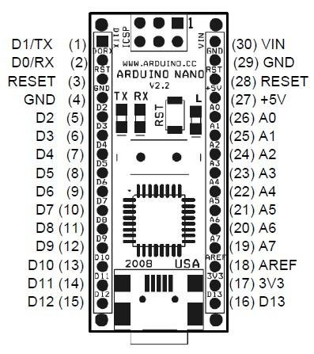

**(24)**